AWS Lab — Security Group + EC2 + Web Server

Using Amazon Web Services and the Amazon EC2 service.

Lab Naming Convention
Resource | Name
Security Group | studentname-sg
EC2 Instance | studentname-ec2

Part 1 — Create Security Group
Go to:
EC2 → Security Groups
Click Create Security Group
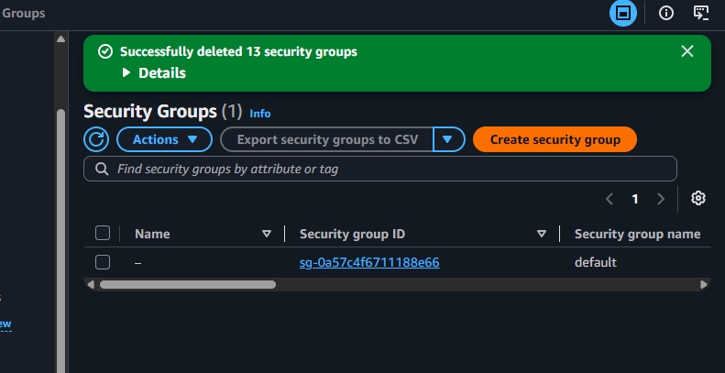
Configuration
Setting | Value
Security Group Name | studentname-sg
Description | Security group for web server lab
VPC | Default
Add Inbound Rules
Type | Port | Source
SSH | 22 | My IP
HTTP | 80 | Anywhere
Result:
Rule | Purpose
22 | SSH access
80 | Web server access
Click Create Security Group
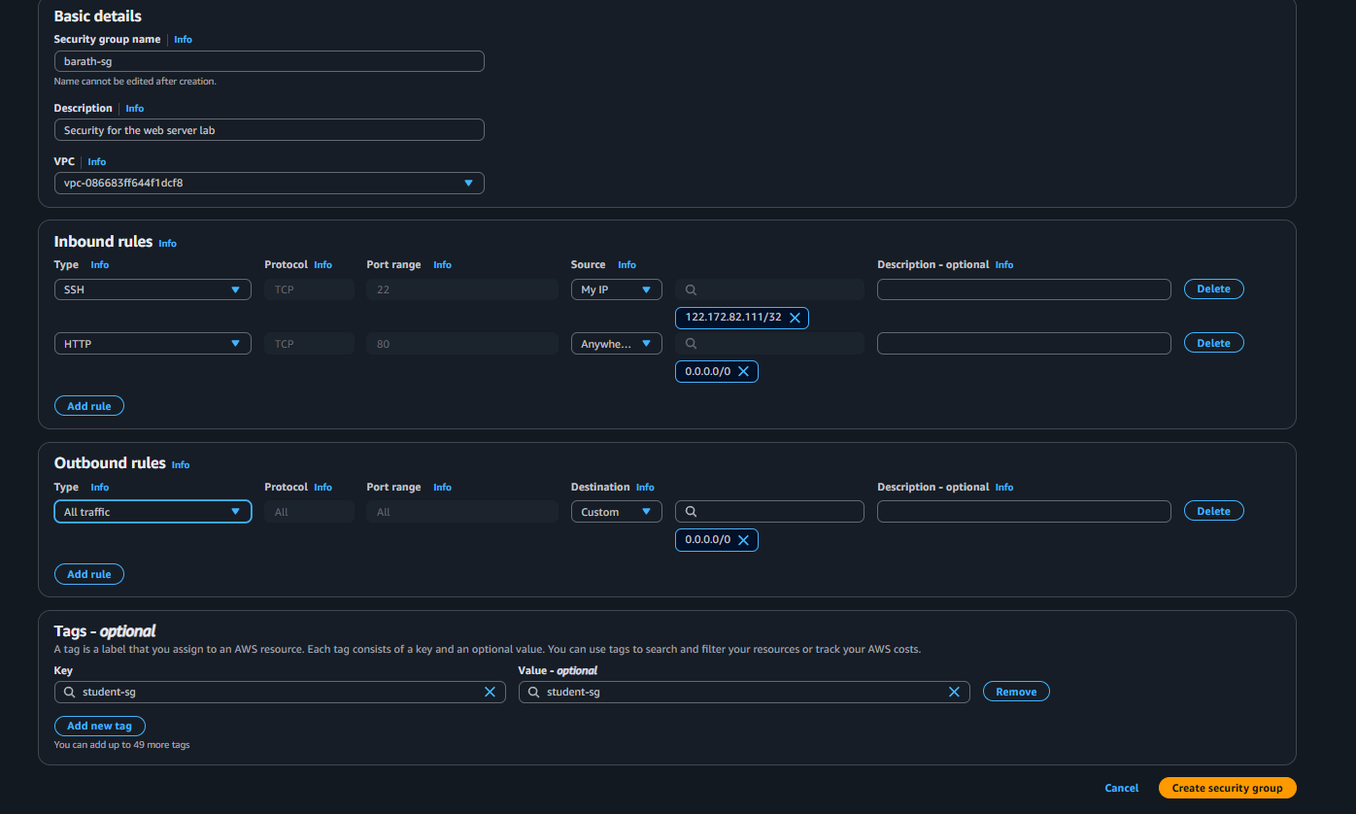

Part 2 — Create EC2 Instance
Go to EC2 → Instances → Launch Instance
Configure Instance
Setting | Value
Name | studentname-ec2
AMI | Amazon Linux 2
Instance Type | t2.micro
Key Pair | existing or create
Security Group | Select existing → studentname-sg
Launch instance.
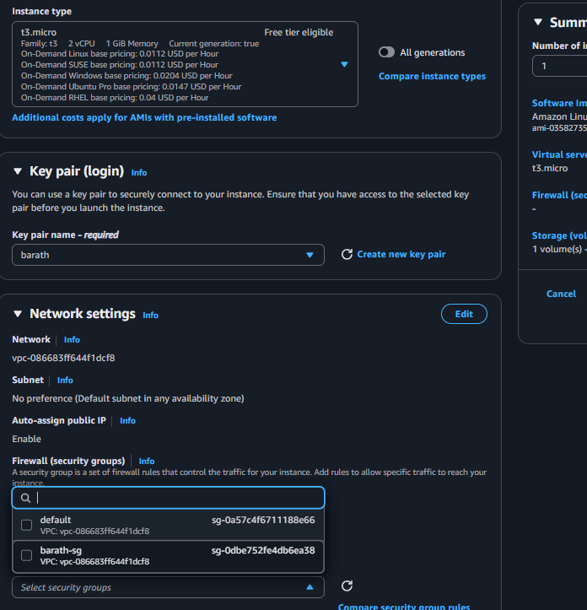
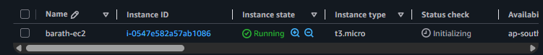

Part 3 — Connect to EC2 via SSH
After instance is running.
ssh -i key.pem ec2-user@public-ip
Verify connection.
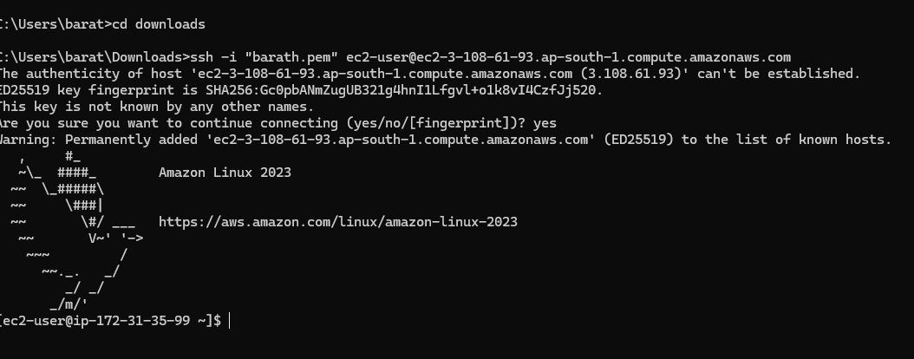

Part 4 — Install Web Server
Inside EC2 install Apache HTTP Server
sudo yum update -y
sudo yum install httpd -y
Start service:
sudo systemctl start httpd
sudo systemctl enable httpd
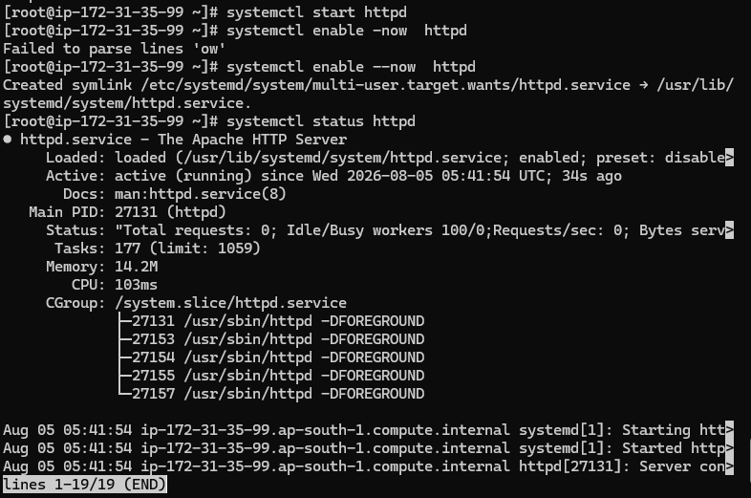

Part 5 — Create Web Page
sudo echo "Welcome to AWS Security Group Lab" > /var/www/html/index.html
Verify
curl localhost
Expected output
Welcome to AWS Security Group Lab
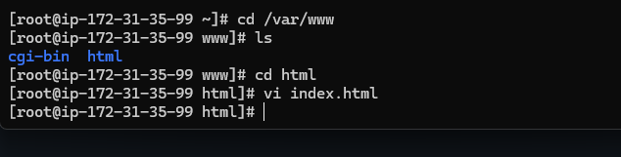
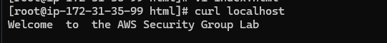

Part 6 — Test HTTP Access
Open browser
http://EC2-PUBLIC-IP
Expected:
Welcome to AWS Security Group Lab
This works because port 80 is allowed in the security group.
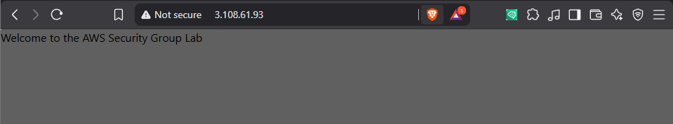

Part 7 — Validate SSH Access
From your laptop:
ssh -i key.pem ec2-user@public-ip
SSH works because port 22 is allowed.

Part 8 — Remove Security Group Rules
Go to:
EC2 → Security Groups → studentname-sg
Edit Inbound Rules
Delete:
Port
22
80
Save rules.
Now no inbound access allowed.
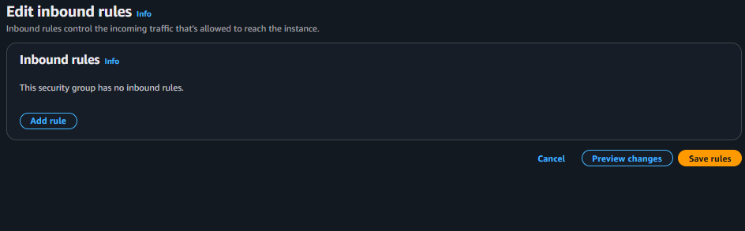

Part 9 — Validate Access After Removing Rules
Test SSH
ssh -i key.pem ec2-user@public-ip
Result:
Connection timed out
SSH blocked.
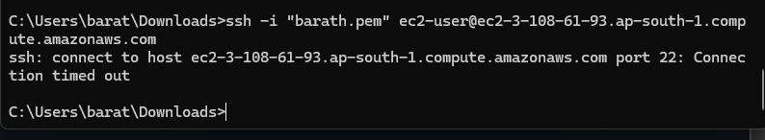

Test HTTP
Browser:
http://EC2-PUBLIC-IP
Result:
Site can't be reached
HTTP blocked.
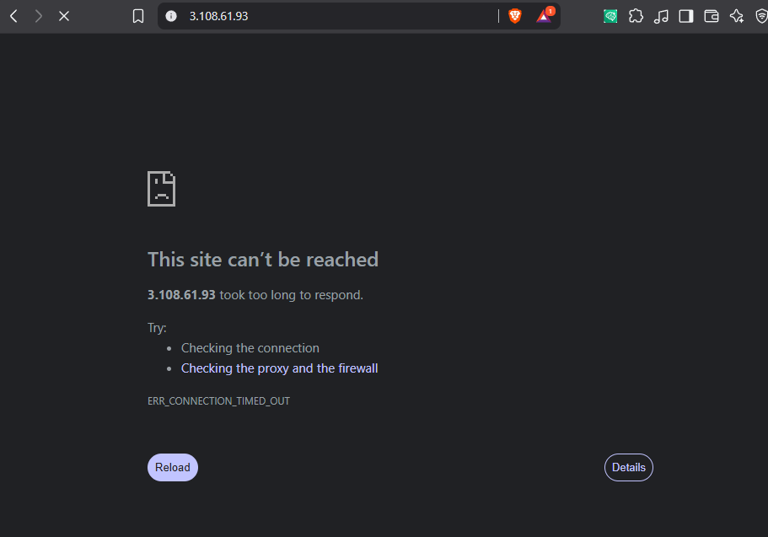

What You Learned
Concept | Explanation
Security Group | Virtual firewall for EC2
Port 22 | SSH access
Port 80 | Web server access
Removing rules | Immediately blocks traffic

Important Concept
Security groups in Amazon Web Services are:
Property | Value
Stateful | Yes
Applied to | EC2 instances
Evaluates | Allow rules only
Default behavior | Deny all inbound

Real Interview Questions
1️⃣ What happens if you remove port 22 while connected via SSH?
Answer: Existing connection continues, but new connections fail.

2️⃣ Are security groups stateful or stateless?
Answer: Security groups are stateful.

3️⃣ Where do we attach security groups?
Answer:
- EC2 instances
- ENI (network interfaces)

4️⃣ Can multiple EC2 use the same security group?
Yes.

